Name: Shaunak Deshpande

IC C

Roll number: 04

GR Number: 11911180

Lab-1

**Multiplication of 2 16-bit nos.**

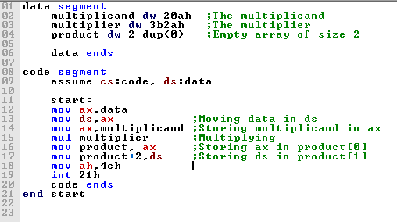

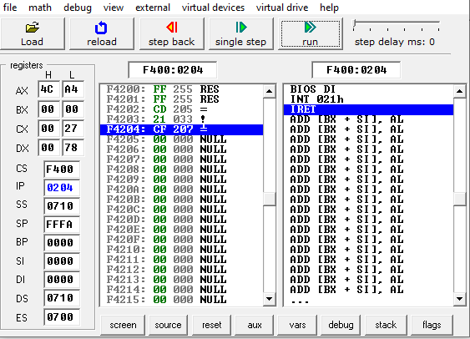

Things learnt from this program were:

1. How to use Data segment
2. How to initialize an empty array
3. How to use data segment in code segment
4. Multiplication of 2 16-bit numbers